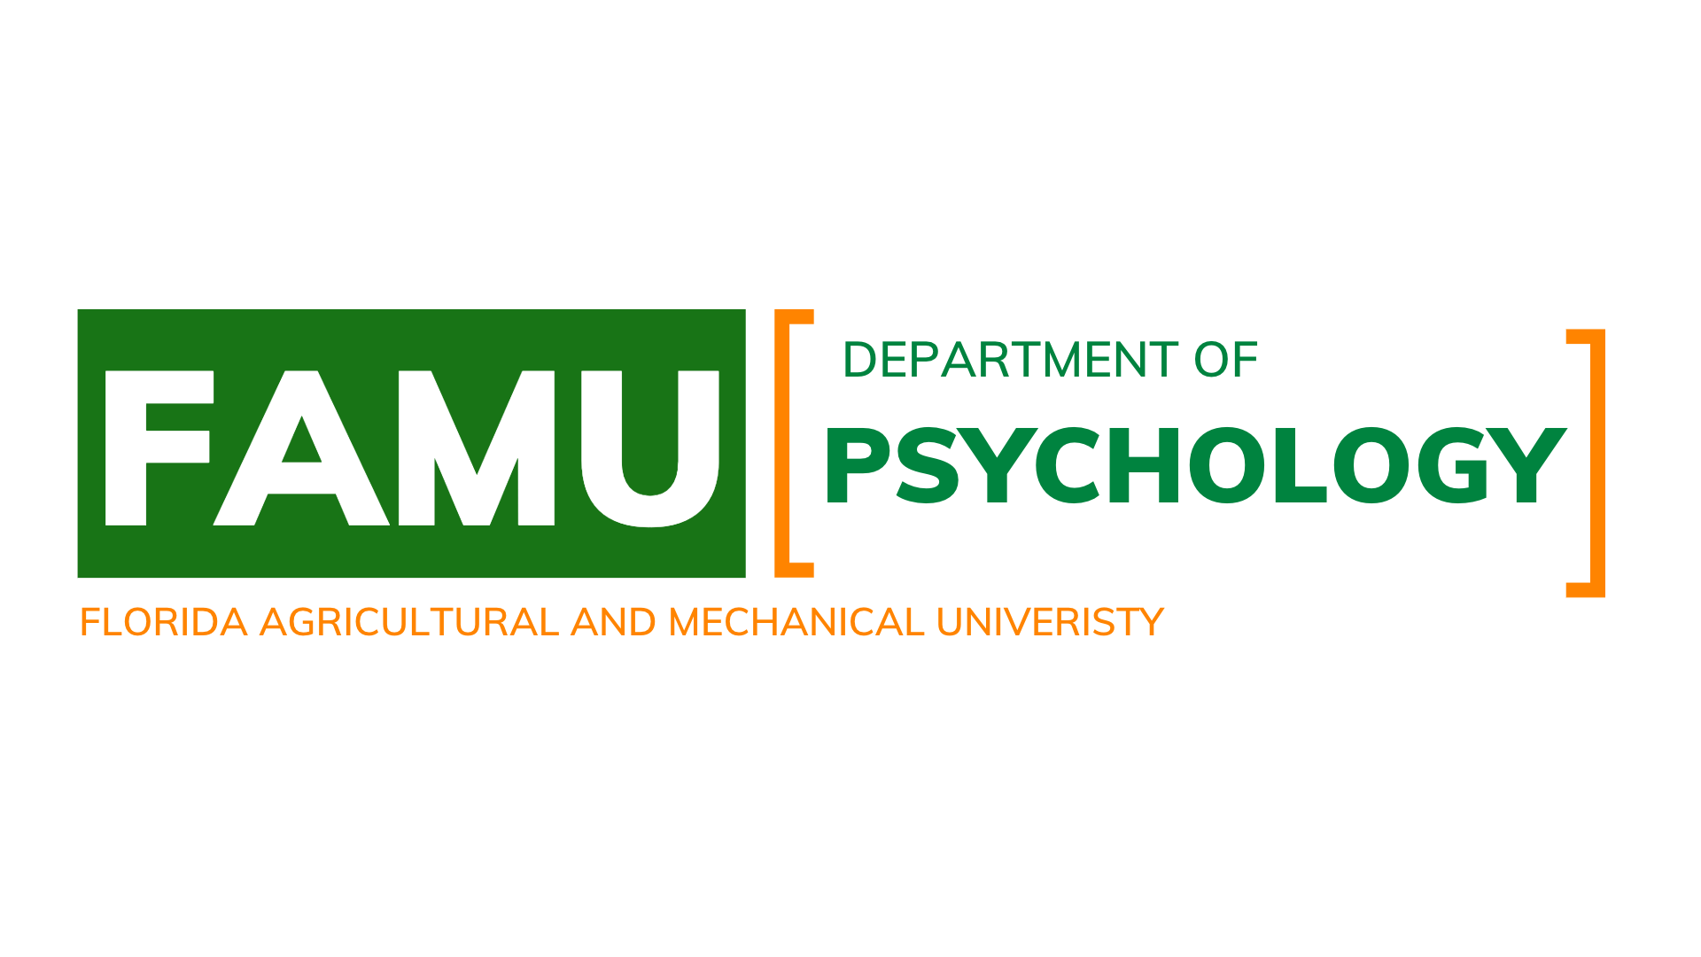
Department of Psychology
STUDENT SUPPORT RESOURCES

February 15, 2023

Academic Resources
I. Academic Advisors
The Department of Psychology is served by academic advisors: contact information is provided below. Advisors serve as the initial contact representative for the department relative to student advisement and play a fundamental role in engaging undergraduate students to ensure their academic success.
The academic advisors also keep records of student's academic progress and meet with students regularly to provide feedback and guidance toward the successful completion of psychology degree programs. They focus on individual academic and developmental needs of each student, spend time with our students to help them solve problems, explain options to them, and help them to make academic decisions (as appropriate).

Contact Information:
Ms. Christina Jackson
Phone Number: (850) 412-6593
Email Address: Christina.Jackson@famu.edu

II. Learning Center
Learning Centers
Summary
The USSC Learning Centers' mission is to encourage investment in learning by supplying students with the tools they need to achieve their goals. We strive to cultivate an environment where students can explore learning, improve their academic skills, and gain confidence in their academic practices.
Locations
- All Subjects |214 & 218 Gaither
- Mathematics|105 &106 Jackson Davis Hall
- Science | 214 Science Hall
- Writing | 124 Tucker Hall
- All Subjects |Coleman Library Lounge
Services
- One-one tutorial support
- Test Review Sessions
- Workshops
Appointment Process
- Visit Famu.TutorOcean.com
- Log in using IRattler credentials

Contact
Renea Pla | Renea.Pla@famu.edu

III. Academic Coaching
Summary
Academic Coaching is a working partnership that focuses on the process of learning. With an academic coach, students examine their learning styles, working habits, and current difficulties or barriers to success.
Locations
- 214 Gore Educational Complex
- 100 MS Thomas
Services
- One-one Academic Coaching sessions
- Workshops
Appointment Process
- https://famu.co1.qualtrics.com/jfe/form/SV_0i8DAgapu1Yom3Q
Contact
Amanda Williams | Amanda.Williams@famu.edu

IV. Math Center on the Set:
The Math Center offers tutorial services in Developmental Math I and II, Liberal Arts Math I and II, College Algebra, Intermediate Algebra, Algebraic & Trigonometric Functions, Precalculus, Calculus I, II, and III, Business Calculus, Differential Equations, and Introduction to Probability & Statistics.
Contact Information:
Phone Number (850) 599-8568
Email address: Studentsuccess@famu.edu

V. Science Tutorial Center:
The Science Tutorial offers tutorial services in the following courses: Biology, Chemistry, Physics, and Biochemistry.
Contact Information:
Phone: (850) 412-7126
Email address Willie.graham1@famu.edu

VI. Writing Resource Center:
The Writing Resource Center offers tutorial sessions in the following courses in English: Freshman Communication Skills I and II, Developmental Writing I and II, and Improving Writing General Writing Assignments.
Contact Information:
Phone Number (850) 599-8391
Email address: wrc@famu.edu

VII. The Career and Professional Development Center:
Offers a variety of ways to work together with the faculty and staff at FAMU to meet the career needs of our students via services, programs, resources, and communications:
• Drop-In Career Assistance
• Mock Interviews
• On-Campus Interviews
• Workshops
• Career Expos & Fairs

Contact Information:
Phone Number (850) 599-3700
Email Address: cpdcenter@famu.edu

